Lab Report – Nutrient Analysis –DUE 11/05/2015
Complete the questions in the following sections. Save the Excel sheet you used to perform all the steps for calculation and email the excel copy and your report to Yinsui_zheng@brown.edu.

I. Lab Note + Background on nutrients
[5 pts] Please copy your note during the lab section. Fill in the information of preparing NO₂ calibration standards. Attach the photo of your standard if you take a picture of it.
# | Label | Concentration (ppb) | Volume (mL)
1
2
3

[5 pts] The samples you selected were analyzed for NH_{4,} NO₃, PO₄, SiO₂, and NO₂. List the molecular weight, charge, and oxidation state of each species in the table below (e.g. +1, -3, +4, etc.).

Compound | Molecular Weight | Charge | Oxidation State
NH₄
NO₃
PO₄
SiO₂
NO₂

[15 pts] Anthropogenic processes can have a significant impact on nutrient concentration. Use the map at http://zhengyinsui.github.io/data.html to find anthropogenic sources that may influence the nutrient concentration of the samples (e.g. agriculture, traffic, septic tanks, urban communities, etc.). Explain how it influences the nutrient concentration.

II. Calibration [50 pts]
Samples were analyzed using a SmartChem200 Discrete Spectrometer (i.e. a research grade analytical instrument priced around ~$75,000-$100,000). Samples undergo a reaction that specifically targets the nutrient being analyzed (e.g. NH₄, NO₃, PO₄, Si, NO₂), the product of which absorbs a certain wavelength of light proportional to the quantity of product in the sample (observable at parts per billion concentration).
In order to determine the nutrient concentration in your samples, we need to establish an equation to convert the raw instrument data (i.e. absorbance) to concentration units (i.e. ppb). We can do this using a calibration curve, built using data obtained from standards of known concentrations. Use the data provided to construct a calibration curve for NH₄, NO₃, PO₄, Si.
Open the file “2015 - Geo1370 - Nutrient Lab Data”. There are two tabs for the file. You can find the known concentration and absorbance for all the analyte (NH₄, NO₃, PO₄, SiO₂, NO₂) in the ‘Calibration’ tab. You can find the absorbance for the samples we collected in the ‘Samples’ tab. R1, R2 are the two rain samples being collected on Sep. 30th.

Standard Calibration [15 pts]
Based on what we learnt from the metal data analysis, calculate the standard calibrations for the nutrient analytes (including slope (m), intercept (b) and R² of the calibrations) using the raw data in the ‘Calibration’ tab. We need to establish a linear regression equation for our data (y = mx + b) in order to convert absorbance to concentration for the samples.
Complete the following table for each nutrient calibration set.
Calibration Model | Slope (m) | Intercept (b) | R²
NH₄
NO₃
PO₄
SiO₂
NO₂

Samples [10 pts]
Apply the calibration curve calculated in the previous section to your samples. Determine the nutrient concentration (ppb) of all the samples. If the value of the computed concentration is negative, correct it to be 0.

[10 pts] Plot the concentration and absorbance values of the standard calibration data for each of the four species examined, with their linear regression lines and equations.
Before applying the calibration to your samples, evaluate the accuracy of your calibration model by examining the residual errors.
- Use your calibration equation to determine the predicted concentration of your calibration standards.
- Calculate the residuals by subtracting the predicted concentration from the actual concentration.
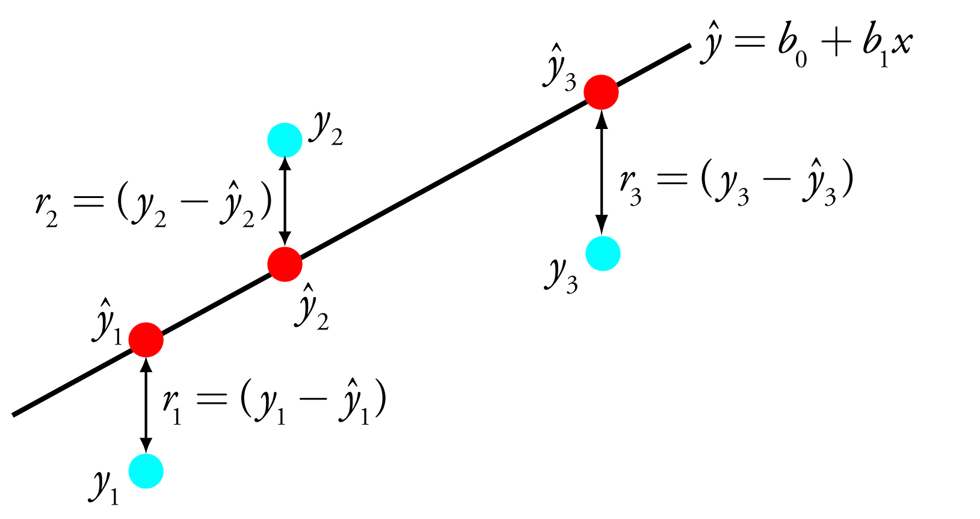
- Here’s an example:
Absorbance | Concentration (ppb) |  | Residuals
Absorbance | Actual | Predicted | Actual - Predicted
-0.019 | 0.000 | 8.399 | -8.399
0.001 | 48.850 | 69.692 | -20.842
0.019 | 97.700 | 122.315 | -24.615
0.034 | 195.400 | 167.762 | 27.638
0.069 | 293.100 | 273.306 | 19.794
0.101 | 390.800 | 367.190 | 23.610
0.173 | 586.200 | 584.258 | 1.942

[10 pts] Plot actual concentration (x) vs. residuals (y) for each calibration model (NH₄, NO₃, PO₄, SiO₂).
Finally calculate the root-mean-square deviation of your calibration model (RMSD) to assess the accuracy of your model.
- In a new column, square the residual values from each row.
- Now calculate the sum of the residuals squared and divide by the number of calibration samples.
- Take the square root of this value to obtain the RMSD value.
Absorbance | Concentration (ppb) |  | Residuals | Residuals²
Absorbance | Actual | Predicted | Actual - Predicted | (Actual – Predicted)²
-0.019 | 0.000 | 8.399 | -8.399 | 70.543
0.001 | 48.850 | 69.692 | -20.842 | 434.388
0.019 | 97.700 | 122.315 | -24.615 | 605.898
0.034 | 195.400 | 167.762 | 27.638 | 763.859
0.069 | 293.100 | 273.306 | 19.794 | 391.802
0.101 | 390.800 | 367.190 | 23.610 | 557.432
0.173 | 586.200 | 584.258 | 1.942 | 3.771
 |  |  | Sum of Residuals² | 2827.695
 |  |  | Divide by # Samples | 403.956
 |  |  | Take Square Root | 20.098 (RMSD)
[5 pts] Calculate the RMSD for each calibration model and report the values below.

Calibration Model | RMSD (ppb)
NH₄
NO₃
PO₄
SiO₂
NO₂

III. Analysis [25 pts]
The environment encodes information about itself through the chemistry taking place within it. For example, information about algal populations in the aquatic environment is encoded in the total nitrogen, phosphorous and silica concentrations (http://lakewatch.ifas.ufl.edu/circpdffolder/nutrpt2.pdf). In order to extract this information from your samples, we need perform the following steps:

[17 pts] Sum the total concentration of all nutrient elements in each sample. The total of all elements is equal to: Total N (N-NH₄, N-NO₃, N-NO₂) + Total P (P-PO₄) + Total Si (Si-SiO₂). Which samples (locations) do you found have relatives high nitrogen nutrient? What might be the possible cause (Related to the interpretation you gave for the anthropogenic processes question in the ‘Background’ section aboved)? (Keep in mind, the goal is not to prove that a process is or is not occurring. We lack the statistical power to do this. Instead try to use the processes and variables you came up with to interpret what you are seeing in the data)

[8 pts] Analyze the Pawtuxet River and HAC nutrient data in the context of your sample map.
Explore the nutrients concentration dataset you got from on Part II analysis or the database on website (http://zhengyinsui.github.io/data.html). Find one trend in the nutrients dataset versus other variable. The other variable may be anything (e.g. pH, dissolve oxygen₃, another metal, latitude, longitude, etc.).

What trend did you find?

- Variable A:

- Variable B:

- Positive/Negative/Non-Linear:

Briefly explain the possible causes.

Compare the nutrients concentrations of rain samples and the water samples we collected from river and Cove. Describe the difference and cause briefly.

